GREENWICH PENINSULA ECOLOGY PARK
MANAGEMENT PLAN

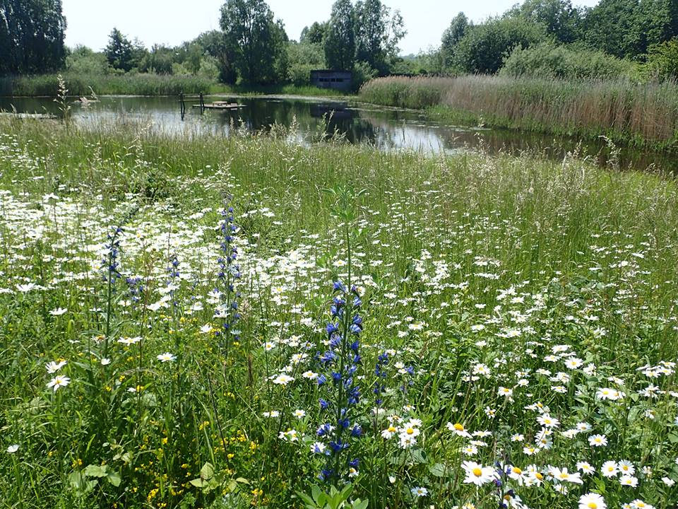

The Land Trust
Birchwood One
Dewhurst Road
Birchwood
Warrington
WA3 7GB

The Conservation Volunteers
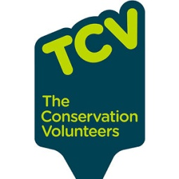
Ecology Park Gatehouse
Thames Path
John Harrison Way
London
SE10 0QZ

www.thelandtrust.org.uk www.tcv.org.uk/greenwichpeninsula

January 2017
Reviewed and amended January 2019

CONTENTS

SECTION 1: INTRODUCTION
1.1 Purpose of the Management Plan 1
1.2 Timescale 1
1.3 Structure 1-2
1.4 About the Land Trust 2
1.5 Role of the Land Trust 2
1.6 About TCV 2-3
1.7 Role of TCV 3
1.8 Role of other delivery partners 3-4

SECTION 2: SITE APPRAISAL
2.1 Context 5
2.2 History 5-6
2.3 Physical Description
2.3.1 Location 7
2.3.2 Geology, soils and hydrology 7-8
2.3.3 Habitats 8-10
2.3.4 Access 10-11
2.3.5 Facilities 11
2.3.6 Capital replacement 12
2.4 Current usage and community involvement 12-14
2.5 Finance and Resources 14-15
2.6 Legal, development and environmental constraints
2.6.1 Conservation status 15
2.6.2 Notes and status of notable species 15-20
2.6.3 Rights of way 20
2.6.4 Planning designations 20
2.6.5 Byelaws, Covenants, Leases, Easements 21
2.6.6 Peninsula development 21-23
2.6.7 Impact of development 23
2.7 Management considerations and constraints
2.7.1 Security and access 23
2.7.2 Current building 24
2.7.3 Increased usage of the park 24
2.7.4 Anti social behaviour 24-25
2.8 Ecological considerations
2.8.1 Reedbed growth 25
2.8.2 Sensitive areas 25
2.8.3 Colonisation by alien species 25-26
2.8.4 Prevention of succession 26-27
2.8.5 Bramble management as site matures 27
2.8.6 Sediment accumulation in lakes 27
2.8.7 Maintenance of compost area 27
2.8.8 Tree growth and coppice rotation 27-28
2.8.9 Brash clearance 28

SECTION 3: AIMS AND OBJECTIVES

Core aims and management objectives 29-33
SECTION 4: VISION UPDATE
4.1 Setting the Vision 34
4.2 Achieving the Vision 34-35

SECTION 5: OPERATIONS PLAN
5.1 Habitat Maintenance Operations
5.1.1 Reedbeds 36
5.1.2 Grassland 36
5.1.3 Open water 37
5.1.4 Wet woodland/carr 37
5.1.5 Hedgerow 37-38
5.1.6 Shingle beach 38
5.1.7 Compost and waste 38
5.1.8 Artificial refuges 38
5.1.9 Redundant top up & recirculation beds 39-40
5.2 Access and Community Operations
5.2.1 Access, tracks, paths & hard standing 39
5.2.2 Capital replacement 39
5.2.3 Patrolling 39
5.2.4 Community involvement 39-40
5.2.5 Formal education & training 40
5.2.6 Informal education 40
5.3 Management/H&S Operations
5.3.1 General management 40-41
5.3.2 Health & Safety 41
5.4 Financial and Resources Operations 41-42

SECTION 6: MONITORING AND REVIEW
6.1 Site Reporting 43
6.2 Management Plan Review 43
6.3 Independent Audit 43-44

APPENDICES
Appendix 1 Greenwich Peninsula Ecology Park Compartment Maps
Appendix 2 Contamination and Remediation details from Greenwich Peninsula Land Management Plan WS Atkins April 2001
Appendix 3 Topsoil/Subsoil specifications from Greenwich Peninsula Land Management Plan WS Atkins April 2001
Appendix 4 Sample Habitat Action Plan produced annually by TCV wardens
Appendix 5 Moth survey 2009 by Dr Tim Freed
Appendix 6 Bee and wasp survey list 2009 by Dr Thomas Ings
Appendix 7 GPEP Fungus Surveys 2010 – 2016 by Clifford Davy
Appendix 8 Bird species presence list 2002 – 2015
Appendix 9 Odonata list 2002 – 2017
Appendix 10 Amphibian list 2002 – 2014
Appendix 11 Provisional report: Invertebrates recorded at GPEP 2016, David G Notton

SECTION 1: INTRODUCTION
1.1 Purpose of the Management Plan

This document sets out the basis on which the site will be managed. This plan will be implemented to achieve the best for wildlife and local communities and will be reviewed as needed but, as a minimum, on a five year basis to ensure it delivers the best for the site whilst meeting the needs of all users.

Greenwich Peninsula Ecology Park is situated within the former gas works and industrial site of Greenwich Peninsula. The site totals 1.72 ha in size and comprises artificial lakes and wildlife habitat, as well as a building and supporting access infrastructure that is managed to provide an important and valued local community asset at the heart of the Greenwich Millennium Village scheme.

The park was transferred from the Homes & Communities Agency (HCA) to the Land Trust (LT) with a dowry to manage and maintain in perpetuity. The dowry recommended is sufficient to maintain the site’s infrastructure, maintain and enhance habitats, and to meet the on-going costs of the proposed management regime and education programme. The Park is currently managed by The Conservation Volunteers (TCV) for the benefit of wildlife and local communities as part of an on-going programme of education and interpretation activities. The purpose of the management plan is:

- To act as a framework within which TCV can manage the site in accordance with the agreed endowment and funding that may be secured from other sources.

- To give an assurance to HCA and Communities and Local Government that the site and the investment within it will be well managed.

1.2 Timescale

The works set out within the management plan include the habitat management works required to maintain the site. The on-going management of these areas will be guided by monitoring and survey works that will inform future application and techniques. The adopted management plan will be developed over the initial five-year period and subject to review based on consultation at the end of this period. The plan will also be reviewed on an annual basis by TCV, LT and other key partners, to take account of changed circumstances.

1.3 Structure

In addition to this introduction, the plan is structured into six main sections. Section 2, Site Appraisal, is a description of the site as it is now, together with current constraints and considerations. Section 3, Aims and Objectives, sets out how the landowners and site managers will ensure the park is managed effectively according to the Land Trust and TCV’s aims and objectives, as well as the future vision for the site. Section 4 sets out the vision for the Ecology Park over the next 5 to 10 years and how this will be achieved.
Section 5, the Operations Plan, sets out what work will be undertaken to achieve these aims and objectives. Finally Section 5, Monitoring and Review, sets out how the success of the plan will be reviewed and updated over time.
The appendices are made up of habitat compartment maps, more details of contamination and remediation, a sample of a Habitat Action Plan prepared annually by the site wardens and wildlife survey data and information where available. Note that wildlife records are currently being collated by volunteers as part of an ongoing project and more data can be requested from the park wardens as needed.
Data and information will be added to this plan as it becomes available and will also be uploaded to www.greenwichpeninsulawildlifeheritage.co.uk

1.4 About the Land Trust

The Land Trust was launched in 2004, becoming a Charity in the independent sector in 2010. It aims to provide long-term sustainable management of open spaces across the United Kingdom.

The Trust ensures the sustainable long term management of sites through securing ownership through freehold, leasehold or management agreements, establishing a funding mechanism to provide revenue funding in perpetuity (ideally through the investment of a capital receipt as an endowment) and appointing a local managing agent to take responsibility for the day to day management of the site.

1.5 Role of the Land Trust

The Land Trust will be the landowner and will hold an endowment to ensure that the site can be managed in perpetuity for the benefit of wildlife and the local community. Its role is to work with The Conservation Volunteers as the managing partner and to ensure that the site is managed in accordance with an adopted management plan, and within the agreed budgets for the site. This will be based on partnership working, ensuring that the roles of the LT, TCV and other partners complement each other for the benefit of wildlife and the local community.

The LT will remain responsible for the maintenance of the buildings, structures and boardwalk access infrastructures and services and electrical and mechanical systems, including the water pumps, aerators and management and supply systems within the site. This includes all relevant periodic PAT testing and buildings inspections. The maintenance of these will be carried out by the LT contractor.

The LT will be responsible for monitoring and payment of all site utilities contracts

The LT is responsible for maintain site infrastructure and security and will make necessary repairs through its appointed contractor.

1.6 About The Conservation Volunteers (TCV)

The Conservation Volunteers help hundreds of thousands of people each year to reclaim local green places. Through environmental projects and a network of 2,000 community groups, TCV allows people to take responsibility for their own local environments.
TCV specialise in a range of activities ranging from re-generation programmes, creating community gardens and Green Gyms to educational and skills-based training; all of which have been demonstrated to improve well-being, mental health and future prospects for those most in need.

1.7 Role of The Conservation Volunteers

TCV will ensure the effective and efficient day-to-day management of the site. TCV are expected to manage the habitats and ecological areas in accordance with this management plan, provide a first point of contact for the local community and other visitors to the site, to organise and deliver a programme of activities and events, and to maintain agreed access networks and basic minor site infrastructure on behalf of the Trust.

Specific responsibilities include:

- To maintain the condition of landscaped areas and habitats in accordance with the agreed management plan.
- To maintain basic site infrastructure including paths, seats and interpretation boards.
- To carry out regular visual basic inspections of key systems and facilities and to report problems (including pump system problems) to LT immediately.
- To act as a first point of contact for the local community and partner organisations.
- To work with established groups and contacts and establish further networks to engage the wider community with the management of the site.
- To provide appropriate warden levels and to report any issues or problems to the Trust immediately and provide regular update reports so that the site is effectively and efficiently managed and the health and safety of visitors is ensured.
- To establish and manage a programme of volunteers to assist with the management of the site.
- To organise and deliver the existing programme of environmental education activities for local schools with the aim of delivering further programmes.
- To organise and deliver a programme of activities in conjunction with the local community, such as summer play and seasonal events
- To seek external funding and partnership support to further enhance the management of the site and deliver greater benefit to the local community.

1.8 Role of Other Delivery Partners

Homes and Communities Agency

The funding for improvements to the site’s infrastructure and endowment for long-term management has been provided through HCA. They have a direct interest in ensuring that this investment is properly safeguarded and that the site is managed to maximise the benefits for local people. This will be exercised through its input into the funding agreement covering the endowment and their continuing role as a partner in the LT.

The Friends of Greenwich Peninsula Ecology Park

The Friends of the Greenwich Peninsula Ecology Park group was set up in 2003 to support the work of the park wardens and has successfully raised funds for a number of practical and play projects through various grant schemes and its own smaller scale fundraising on site. The group is recruited from people in the local area, including local residents, volunteers and birdwatchers, and meets approximately once every 2 months. Group members also help out with park activities and events in liaison with the park wardens. The Friends group was registered as a charity with the Charity Commission on 30 May 2007.

Royal Borough of Greenwich

The Ecology Park is an important open space, wildlife habitat and community facility in the Royal Borough of Greenwich (RBG). The park wardens liaise with the local ward councillors and have had input into the Greenwich Biodiversity Action Plan. Links have been established with council departments and groups in the borough, such as Greenwich Wildlife Advisory Group. The Park also provides an important service to RBG schools.

Other organisations

TCV adds to its expertise by drawing on the resources of a range of organisations best placed to deliver aspects of the site’s management on its behalf. TCV also liaises and partners with other organisations where appropriate, eg. Froglife, London Beekeeper’s Association

SECTION 2: SITE APPRAISAL

2.1 Context

The Greenwich Peninsula Ecology Park is one of several greenspaces built within the wider Greenwich Peninsula development including Southern Park, Central Park, Riverside Walk and the intertidal terraces. Located adjacent to the Thames Path, the park provides a green oasis at the heart of the Greenwich Millennium Village (GMV) development on the Peninsula.

At the northern end, the site runs alongside the Thames, connecting with Southern Park at its southern end. The centre of the Ecology Park is at grid reference TQ399793. Immediately alongside the site’s western boundary stands the GMV development with the outer lake overlooked by residential balconies. The eastern edge is currently being developed as housing.

The first phases of development were coordinated through a Greenwich Peninsula Land Management Plan on behalf of English Partnerships in April 2001, produced by WS Atkins Consultants Ltd in association with Nicholas Pearson Associates (available to view at www.greenwichpeninsulawildlifeheritage.co.uk). This sought to balance the development with provision for a network of connected green spaces, which included Greenwich Peninsula Ecology Park, Southern Park (formerly Millennium Village Green), Central Park, the riverside and various pocket parks.

This plan was replaced in 2004 with Terry Farrell & Partners’ masterplan for the Peninsula - a £4 billion project agreed with English Partnerships, developer Meridian Delta, Anschutz Entertainment Group and Greenwich Council. This scheme included 10,000 new homes, on a plot-by-plot basis with new developers and architects appointed at each stage, and the 20,000 seat area in the Millennium Dome (now the O2).

Peninsula development has changed significantly since then due to recession, changes in government at a national and London level, changes in acoustic regulation (affecting GMV), changes in development companies, a change of emphasis from business to housing (affecting the Knight Dragon development) and increased density of housing (affecting both development areas).
The Allies and Morrison reworking of the 2004 masterplan in 2015 included 12,678 new homes, 60,000m² of new business space, 24,000m² of new retail and restaurant space, two new schools and a new ferry terminal. It will also see the demolition and complete rebuild of North Greenwich tube and bus station, construction of a new healthcare facility, and the expansion of the Ravensbourne digital media college. It will create a district formed of five neighbourhood zones. Knight Dragon was appointed as developer of this new scheme.
2.2 History

Greenwich Peninsula was first recorded in 918 AD as being an area of marshland. The first
human intervention came as the marshland was reclaimed and turned into farmland and later
market gardens, whilst the riverside remained the focus for whitebait fishing.

The Greenwich Peninsula was however prone to flooding and as a consequence it remained
undeveloped until the 19th century. Offering direct access to the river, the Peninsula was developed for industrial use, including the importing and exporting of goods and the manufacture of munitions, chemicals, steel, cables, rope and soap. These industries were then dwarfed by the opening of the gasworks in 1887 which soon expanded to become the largest gasworks site in Europe.

For almost 100 years Greenwich Peninsula supplied gas to communities across south-east
London, before changes in the industry saw the gasworks become redundant in the 1980s.
By the mid-1980s Greenwich Peninsula was largely derelict and contaminated by industrial
waste. English Partnerships (EP), the government regeneration agency of the time, acquired 121 ha of land on the Peninsula from British Gas in 1997 in order to co-ordinate the comprehensive regeneration of the Peninsula.
Prior to its creation, the Ecology Park site was part of the larger gasworks that dominated the Greenwich Peninsula. Specifically, the Ecology Park site was owned by Redpath Brown and operated as a steel stocking yard through the 1950s and 1960s closing in the 1970s and lying derelict until EP’s reclamation works in the late 1990s.

The Ecology Park was created as part of the early phases of decontamination and regeneration of the Greenwich Peninsula to recreate and re-establish elements of the Peninsula’s original marshland heritage.

Since its creation in 1998/99 at a cost of c.£10.5 million, the Ecology Park has matured and has become home to a thriving wildlife community of water fowl, invertebrates and small mammals including some species that are nationally rare and under-recorded in London. The Ecology Park has been created alongside Southern Park and forms a green ‘heart’ to the Greenwich Millennium Village scheme.

More historical information can be found at www.greenwichpeninsulawildlifeheritage.co.uk

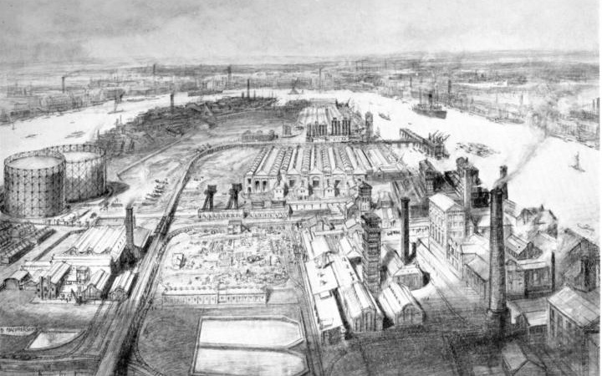
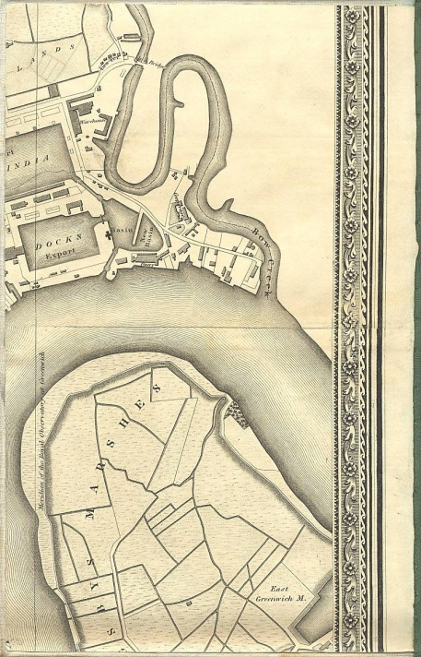
Above: 1920 sketch of Greenwich Peninsula
Left: From Greenwood’s map of London 1827
2.3 Physical Description

2.3.1 Location
The centre of the park is at grid reference TQ399793.
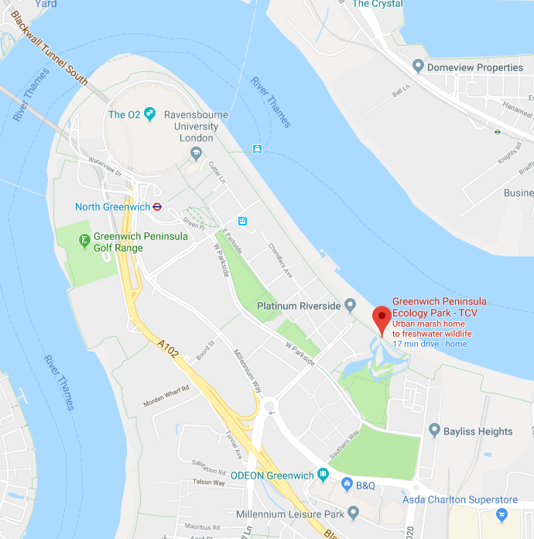

2.3.2 Geology, Soils and Hydrology

- Details of the historical nature of contamination and remediation works on the Greenwich Peninsula can be found in Appendix 2 (from the original Peninsula masterplan)
- A clay cap underlies the site and there is a bentonite wall between the marsh and the river wall
- Hydrology is artificially controlled by an installed system of pipes, pumps, overflows and valves. Not all of this system has functioned properly over the years.
- The lakes are topped up from a chalk borehole source for which an abstraction licence has been granted by the Environment Agency. This was originally designed to flow through the concrete channels and filter beds at the top of the shingle beach but is now pumped directly into the lakes. Water levels can be lowered by draining into the Thames via a sluice located underneath the boardwalk on the northern approach to the entrance building. The original borehole was close to the O2 but was replaced in 2017 by a smaller borehole in Southern Park (also owned by the Land Trust) adjacent to the Ecology Park. This can currently top up the lakes via a hosepipe but planned works in 2019 will directly connect the new borehole to the existing underground water system.
- When the system is fully working, water can also be re-circulated in each lake. Water from the inner lake was originally further filtered through a raised reed bed – this has not functioned for several years. C Elect currently have a contract to maintain the water systems and top up the levels as requested by the Park Wardens. This maintenance contract takes the form of regular checks with any necessary works undertaken.
- The water circulation and pumping system was originally controlled via a computerised system situated in the Gatehouse but is now operated via electrical cabinets in the hides. This is due for review and will be modernised and simplified as technology and funds allow. An operating handbook for the lake filling, aeration and water recirculation systems is kept in the Gatehouse.
- An important aspect of the site’s management is to manage environmental liabilities and obligations. These responsibilities will remain with LT. In addition, there is an obligation to ensure that the Abstraction Licence with the Environment Agency is complied with and that the Pumps and electrical systems are maintained. LT employs a specialist contractor (C Elect) to fulfil this role, including periodic maintenance and repair / inspection. TCV as the managing agent is responsible for reporting any breakdown or problems with the system to the appointed LT contractor and/or to LT.
- All soils and substrates were imported or manufactured on site. The specifications that apply to different areas are summarised in Appendix 3 (from the original Peninsula masterplan)
- Overall levels across the Peninsula are relatively flat. The local levels within the Ecology Park are:
  - Lower level riverside walk at 5.2m to 5.7m AOD, separated from the Ecology Park by a retaining wall, the levels at the back of the wall being 6.5m to 7.2m AOD
  - The deepest part of the inner lake is 2.85m AOD
  - The bed level of the outer lake varies between 4.25m and 4.5m AOD

2.3.3 Habitats

- The Ecology Park is a man-made environment that is dominated by freshwater habitats. The site also contains a number of other specially constructed environments each tailored to the needs of certain sets of wildlife. This has provided an integrated and sustainable environment and wildlife haven.
- The site is surrounded by residential developments at Greenwich Millennium Village. Landscape design for the site has been given careful consideration to ensure the integration of areas of habitat, open space and access networks. Key features include two separate areas of open water with a large stand of reedbed, willow woodland, carr and smaller areas of species rich florally diverse grassland and shingle habitats.
- The Ecology Park is divided into 2 main sub areas - the outer lake area has public access at all times and the inner lake area has controlled access via the Gatehouse. The major habitat elements are summarised as follows:

Habitat Element | Description | Area
Reed bed and marsh | Large stands of Common Reed plus emergent plants on the shallow margins of the lakes, including Flowering Rush, Sweet Flag, Marsh Marigold and Yellow Flag Iris. | 0.18 ha
Open water | Supplied by freshwater from a chalk borehole, the Park has a series of water bodies of various depths and sizes, including 2 large, deeper lakes, a smaller pond and an ephemeral pool as well as streams flowing through the alder carr. Both lakes have areas planted with native water lilies. Note that the inner lake and outer lake are completely separate and the water does not mix. | 0.86 ha
Grassland | Areas of mixed grasses and wild flowers including wet and drier meadow areas and a walk-in meadow area where public access is allowed. | 0.12ha
Shingle beach | Two areas of sandy soil, rocks and pebbles – a pioneer habitat populated mainly by annuals – one large sloping shingle bank alongside the inner lake and one smaller flat strip of beach between the two bird hides. There is also a spit and smaller shingle areas along the inner edge of outer lake. This habitat supports a range of annual plant species such as Wild Carrot as well as some important biennials such as Viper’s Bugloss. It serves as a basking and feeding area for many butterfly species as well as supporting many other invertebrate species including Hymenoptera (ants, bees and wasps), Orthoptera (grasshoppers and crickets) and Tricoptera (caddis flies). | 0.20ha
Willow beds | Areas of willow woodland with various species of willow – mostly Osier, Grey and Purple - managed by coppice rotation – with some willow, birch and alder standards and willow pollards. | 0.18ha
Alder Carr Woodland and Streams | An alder dominated woodland in wet to waterlogged conditions with a wet meadow area and associated flora. Includes a network of streams fed by pumps using water from outer lake. Also in the carr are Silver Birch, Pedunculate Oak, Aspen and Ash as well as smaller shrubs such as Spindle, Elder and Guelder Rose. Wildflower bulbs have been planted in the glade area. | 0.18 ha
Hedgerow | The top and end boundary of the inner lake area is formed by a hedgerow of mixed species including Hawthorn, Blackthorn, Guelder Rose, Gorse and willow. As well as a thorny barrier to deter access to the site over the boundary wall, the hedgerow provides an important habitat for birds. Additional wild rose species were added in the area close to the Gatehouse to further deter unauthorised access.
Boardwalk and fencing | Wide wooden boardwalks leading through different habitats allowing good, safe disabled and buggy access. Some habitats in the inner park are shielded by woven willow fencing. | 600m
Artificial refuges for wildlife | Bat tower (not in use by bats), tern rafts (in use by nesting Common terns), newt hibernacula, standing deadwood, bird and bat boxes, bee and minibeast towers and boxes. The original large, part buried standing deadwood has gradually been replaced by smaller deadwood features in greater quantities. There is a beehive in a former top up filtration bed at the far end of the shingle beach, maintained by professional beekeepers.
Redundant top up and recirculation beds | The top up beds either end of the shingle beach area are now shingle areas (formerly reed filtration beds) – one is used for storage of willow and materials, the other is used to site a beehive and managed as a shingle type habitat with annual plants.  The recirculation bed was originally planted with reeds but has now dried up and is maintained as a shingle habitat. There is a deep pool at one end with aquatic vegetation including non native water lilies.

2.3.4 Access

- Access into the outer lake area of the Ecology Park is 24 hour, seven days a week. The outer lake area has a wide wooden boardwalk with gates at either end. The gates were added in 2004 (and replaced in 2008) to mark the area out from its surroundings as an ecology park and to prevent cyclists going through. The gates are due to be replaced in 2019 and a large wooden archway sign will be added as an entrance way into the alder woodland to mark the start of the Ecology Park. The gates are sourced from a specialist company as easy to open, self-closing and able to be used by people in wheelchairs. The area under the trees has plastic grip matting fixed in place. Parts of the outer boardwalk are due to be replaced in 2019. Many people only use the outer boardwalk and it is used by GMV residents as a pleasant through route to the bus stops. The outer boardwalk is lit at night by a series of lights, which are timed to come on automatically at dusk and are maintained by contractors. The boardwalk edges are now fenced to shoulder height along its length - earlier low rails were replaced in 2007 due to people and dogs going into the habitats and causing damage. Wardens have added low level woven willow fences and planted hedgerow shrubs along the edge with Southern Park to further deter access and damage.
- Access into the inner lake area is controlled via the Gatehouse and is open to the public between 10am and 5pm (or dusk in winter), Wednesday to Sunday throughout the year, except for 2 weeks at Christmas. The inner park has a network of wide, wooden boardwalks offering excellent disabled and buggy access. Large areas are fitted with chicken wire to increase grip in cold or wet weather, when the wood can become very slippery. There are low and high wooden rails at the edges of the habitats and willow panel fencing along the lake edges.
- Although the Park is closed to the public on Mondays and Tuesdays, school and community group bookings are taken on these days. The inner park is also open on all Bank Holidays apart from Christmas.
- There is machinery access via John Harrison Way. The wardens also hold keys to the bollards at the end of John Harrison Way for access by Trust vehicles and for disabled parking.

2.3.5 Facilities
- A multi-purpose building called the Gatehouse is used as a visitor centre, volunteer room, storage facility and event venue. Its use is, however, restricted by it also being the entrance through to the inner park and access to the disabled toilet. There is a small office and kitchen within the gatehouse. The gatehouse is due for a refurbishment and this is currently being planned and costed,
- Visitor facilities include a chalkboard for wildlife sightings, leaflet area, visitor’s book, wildlife diary, large display area for temporary displays, a permanent metal and perspex display board explaining the water system, bench seating doubling up as storage, a table and chairs for colouring and art activities and a selection of wildlife themed books. There is also a small area for the sale of gifts, cards and books in aid of the Friends group.
- A covered veranda just outside the gatehouse has wooden tool storage chests and access to 4 extra toilets (used for school visits and events)
- A new wooden education building or outdoor classroom was completed in spring 2018 on the site of the old pond dipping platform and waiting area. The building was funded by grants from Veolia Environmental Trust, the Postcode Local Trust and the Bernard Sunley Charitable Foundation, Section 106 funding from IKEA, plus fundraising efforts by the Friends of the Park and local supporters and residents. It was designed by Edward Architecture and an add-on pond dipping platform is due to be completed in spring 2019. The side walls will gradually be covered with wall planters and minibeast habitats, constructed by local children and local and corporate volunteers. The building is currently used for park events, school class activities, volunteer and staff training, meetings and holiday workshops. There are plans to hire the building to outside groups for meetings to raise income for the site.
- The two wooden bird hides (east and west) have disabled access and overlook the inner lake (one with limited tool storage).
- A large circular interpretation panel in the middle of the Park detailing the habitats and typical species is due to be replaced by a more interactive wooden structure when funding allows. The new structure will also have a second storey viewing platform
2.3 6 Capital replacement

- The endowment calculation for the site provides for the capital replacement of certain, mainly hard, landscape elements that have a finite lifespan. These include:

- Hard surfacing including paths (10 years)
- Security fencing (10 years)
- Sluices / water control structures (10 years)
- Information boards (5 years)

- Replacement works include ongoing management requirements in respect of soft works (grassland, wetlands), timber (footpaths/boardwalks, seating areas, nesting boxes), boundary treatment (wattle screening, perimeter fencing), drainage, structures (building, toilets, bird hides), interpretation boards and signage, and other elements such as electrical systems. These are seen as intrinsic to the on-going operation of the site as part of the maintenance programme, rather than optional capital works and as such allowance has been included for replacing these within the dowry sum.

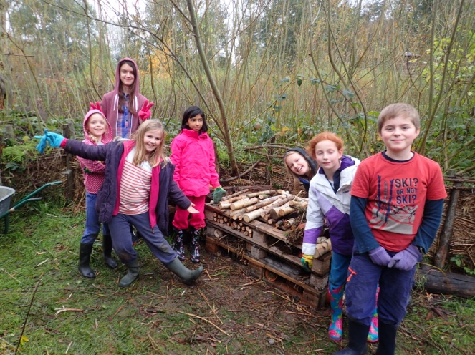
2.4 Current usage and community involvement

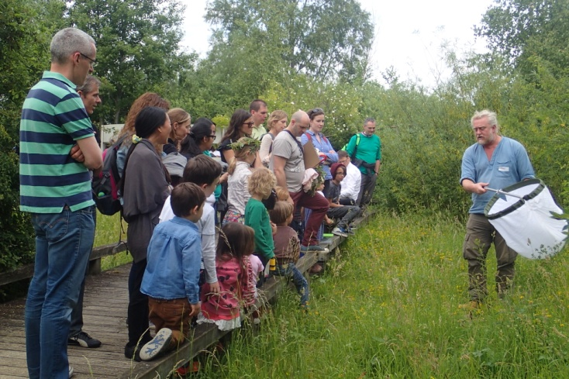
The site has a well-established public access network and activities programme which includes education, events, holiday activities for families and children and volunteering opportunities.
- The inner park area is open to the public 5 days a week (Wednesday – Sunday), 10am to 5pm or dusk.
- School sessions are delivered mainly on 2 days a week, Mondays and Tuesdays, with full access to the site when the park is closed to the public. The site becomes fully booked between March and July with some additional sessions booked on other days to accommodate high demand. Autumn sessions are also available. The service is open to all London schools but is so popular, with many repeat bookings each year, that it is no longer promoted widely as the site would not be able to meet demand. Both wardens are involved in the delivery of education visits, together with help from key volunteers. Information sheets, health and safety guidelines, booking forms and feedback forms are produced by the wardens and updated annually. Site visits are charged.
- School visits are closely tied in with the National Curriculum and offer hands-on tours and a range of group activities, including pond dipping, birdwatching, quizzes and environmental art. As the pond dipping area is only suitable for 10 children at any one time, classes are usually split into 3 groups and offered 3 different group activities. The additional wooden education building by the pond dipping area has provided much needed extra space for wet weather and indoor activities, as well as extra space for classes to eat lunch and store bags.
- Work experience placements are organised for Greenwich and Lewisham secondary school students and trainee teachers at the University of Greenwich (approximately 5 per year)
- Drop in activities such as quiz trails, colouring pages and word searches are available during opening hours. These are seasonal or relevant to the park and offer informal ways of learning about urban wildlife or environmental and science topics.
- In addition to the more formal interpretation panels, there is a large area in the gatehouse for temporary displays. These are changed regularly and inform visitors about the park and its wildlife or about environmental topics. Chalkboards in the hides and gatehouse are regularly updated with wildlife sightings. There is also a range of wildlife and identification books in the gatehouse which visitors can check, read or take round on their visit.
- Outreach work off site is limited by time available and the need for staff to cover opening hours on site. However in the past this work has included community garden projects, talks to community groups, school assemblies and help with school wildlife gardens.
- Events are organised throughout the year, including an annual Frog Day in March, a Dawn Chorus walk in May, a Wild Day Out in June and a Winter Fayre in December. The December event is important to encourage visits during the winter months. Other smaller events are organised on a more flexible basis, according to funding and staff time and have included summer evening events and special art days.
- Wardens work with the Friends group each year to raise funds for a programme of summer holiday activities and events for families and children.
- Guided tours are offered to community groups and higher education students
- People from the local community have a variety of opportunities to volunteer at the Park, including:
  - Regular volunteer practical workdays on Wednesdays and Saturdays from September to May.
  - A weekend Urban Ranger scheme - volunteers are trained to join a team of rangers who help warden the park and meet and greet visitors at weekends on a rota basis
  - TCV’s Volunteer Officer scheme – volunteers commit to 3 days a week for 6 months in exchange for free training and mentoring and an opportunity to gain valuable work experience in the field of conservation. 2 Volunteer Officer Wardens and 1 Education Volunteer Officer are recruited each year.
  - Events volunteering – assisting with seasonal event and school holiday activities
  - Friends of the Park volunteering – attending meetings, helping to fundraise and filling posts such as Chair and Treasurer
  - Volunteers help record wildlife on site and maintain records
  - A Young Urban Rangers project was funded for one year allowing 8 to 15 year olds to become involved in supervised practical work at the park. Funding is being sought to continue this popular project.
- Park staff continue to liaise with Greenwich Youth Offending Service to offer reparation work for young offenders.
- TCV and the Land Trust organise Employee Action Days where corporate teams can take part in habitat management tasks and challenges.

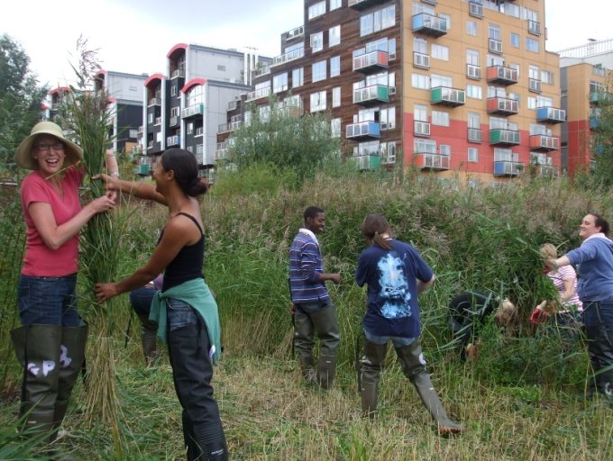
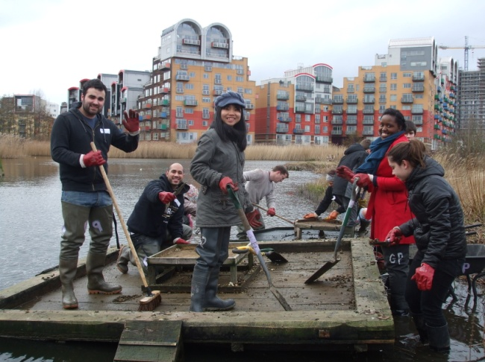

2.5 Finance and resources

- The endowment held by LT is invested to generate an annual income to allow the basic physical management works to be undertaken, including routine maintenance and temporary maintenance operations, and planned capital replacement works. It also covers basic staffing costs, including 2 full time employees.
- The basic level of income generated through the endowment is supplemented by additional income from other sources where possible. This includes education and filming income but may also include grants to undertake specific projects. This additional funding is secured by the Friends group, TCV, LT and joint partnerships between them.
- The site has two full time TCV employees – a Senior Warden and a Project Officer. They work together on site 3 days a week and alone for the other 4 days on a shift pattern. Cover wardens are subcontracted from a pool of appropriately experienced TCV approved contractors.
- 2-3 Volunteer Officers (commitment of minimum 6 months, 3 days a week) assist with volunteer practical workdays, events, education visits and a range of other work on site according to experience and interest.
- Up to 12 weekend volunteer Urban Rangers (commitment of 2 days per month on a rotational basis) assist with wardening the park and meeting and greeting visitors at weekends.
- The park leaflet features a location map and details of the habitats found, opening hours and information on wildlife and activities. Leaflets are distributed at the Gatehouse and to all visiting schoolchildren as well as at various sites around the borough including Greenwich Tourist Information Centre. Leaflet text and photos have been updated four times since the Park opening and need regular review. Leaflets are produced within the site budget.

2.6 Legal, development and environmental constraints
The following paragraphs provide a background to any legal constraints and other restrictions within Greenwich Ecology Park.

2.6.1 Conservation status

- It is hoped that the site will be considered for Local Nature Reserve status by RBG. At present, the site is listed as a Site of Borough Importance Grade 1
- On-going surveys of the botanical, invertebrate and bird interest of the site shows it be of local and London importance with some nationally important species.
- It is envisaged that the conservation interest of the site will increase over time as the site matures and with appropriate management of the existing habitats. However, it should also be noted that some species and habitats will be affected by future development around the site. This may be due to surrounding habitat loss and degradation, reduction in the overall size of habitat available (loss of surrounding fields to development) and increasingly dense development of the rest of the Peninsula.
- The following surveys are currently undertaken in the Ecology Park when time and staffing levels permit:
  - Survey of Odonata (dragonflies/damselflies) March to November
  - Survey of Lepidoptera (moths/butterflies) March to October including summer moth trapping
  - Surveys of birds, including nesting birds
  - Small mammal trapping, September
  - Torchlight surveys for amphibians in spring
  - Quarterly fixed point photos at set points – April, July, October, January
  - Invertebrate surveys – ongoing list of species.
  - Flowering plants lists and more extensive botanical surveys where possible

2.6.2 Notes and status of notable species

BIRDS

Scientific name | Common name | Status | Notes
Sturnus vulagris | Starling | BoCC4 Red List  London BAP priority species | Breeding in Yacht Club building adjacent to Park and regular visitor
Motacilla cinerea | Grey Wagtail | BoCC4 Red List | Regular visitor and breeding in park
Carduelis cannabina | Linnet | BoCC4 Red List  UK BAP species  London BAP priority species | Occasional winter visitor now fields behind Park have been redeveloped
Emberiza schoeniclus | Reed Bunting | BoCC4 Amber List  UK & London BAP priority species | Has bred in Ecology Park, current visitor
Sterna hirundo | Common Tern | BoCC4 Amber List | Breeds on tern rafts on inner lakes every year
Prunella modularis | Dunnock | BoCC4 Amber List | Present all year round and breeds in park
Falco tinnunculus | Kestrel | BoCC4 Amber List | Fairly regular visitor to Park
Delichon urbicum | House Martin | BoCC4 Amber List | Annual summer visitor to Ecology Park
Gallinago gallinago | Common Snipe | BoCC4 Amber List | Regular winter visitor
Alcedo atthis | Kingfisher | BoCC4 Amber List | Regular winter resident
Anas platyrhynchos | Mallard | BoCC4 Amber List | All year round and breeds in park and on rooftops/balconies in surrounding area. Extra winter visitors annually.
MAMMALS

Scientific name | Common name | Status | Notes
Pipistrellus pipistrellus | Common Pipistrelle bat | Wildlife and Countryside Act, 1981 protected. European Habitats Directive protected. UK & London BAP priority species | Regular visitor to Ecology Park – feeding on site over carr
VASCULAR PLANTS
Scientific name | Common name | Status | Notes
Populus nigra betufolia | Black Poplar | London BAP priority species  Britain’s most endangered native timber tree | Growing along river path outside Ecology Park
INVERTEBRATES

Scientific name | Common name | Status | Notes
Chalcolestes viridis | Willow Emerald Damselfly | Recent colonist to UK | A very few twentieth century records, but recorded in numbers from southeast Suffolk during 2009, with outlying sites in southeast Norfolk and north Essex. In 2010 again present in these areas, with additional records from south Essex and north Kent.
Heriades rubicola | Hymenoptera/Megachilidae |  | 2nd British specimen. Found inn Southern Park. David G Notton 2016-17
Hoplitis adunca | Hymenoptera/Megachilidae |  | New to Britain, only known British colony is GPEP  David G Notton 2016-17
Isodontia Mexicana | Hymenoptera/Sphecidae |  | New to Britain, only known British site  David G Notton 2016-17
Lucanus cervus | Stag Beetle | UK BAP priority species  UK scarce  London BAP priority species  London SAP | Brought in as larvae in dead wood. Adults sighted in Ecology Park.
Andrena pilipes | Mining bee species - no common name | RDB3 Nationally Scarce | 2009 survey by Dr Thomas Ings, 2016/17 survey by David G Notton
Heriades truncorum | Solitary bee species – no common name | RDB3 – very rare | 2009 survey by Dr Thomas Ings
Bombus humilis | Brown-banded Carder Bee | UK BAP priority species | 2009 survey by Dr Thomas Ings
Caloptilia falconipennella  Gracillaridae | Moth species – no common name | Designated pRDB3 though apparently increasing in recent years; discontinuously throughout Britain north to Dunbartonshire. | 2009 survey by Dr Tim Freed
Phyllonorycter strigulatella  Gracillaridae | Moth species – no common name | Nb  Nationally scarce, occurring in very local, isolated colonies in central southern England, the southern Welsh border counties and Derbyshire. Rare and local in London | 2009 survey by Dr Tim Freed
Phalonidia manniana  Tortricidae | Moth species – no common name | Na  Nationally scarce in southern England, but also in north Wales eastwards to Yorkshire. Extremely rare and local in London | 2009 survey by Dr Tim Freed
Calamotropha paludella  Pyralidae | Moth species – no common name | Nb  Scarce and locally distributed in southern and south-east England, with some records as far north as Cheshire and Lancashire. Rare and local in London | 2009 survey by Dr Tim Freed
Schoenobius gigantella  Pyralidae | Moth species – no common name | Nb  Nationally scarce, in reed-beds, in parts of southern England, with records north to Yorkshire, predominantly coastal. Very rare in London | 2009 survey by Dr Tim Freed
Calophasia lunula  Noctuidae | Toadflax Brocade moth | RDB  Endangered, south-eastern England, predominantly coastal | 2009 survey by Dr Tim Freed
Archanara sparganii  Noctuidae | Webb's Wainscot moth | Nb  Now well established but local in south-east England; also Welsh coasts. Very local and uncommon in London | 2009 survey by Dr Tim Freed
Earias clorana  Noctuidae | Cream-bordered Green Pea moth | Nb  Scattered locally throughout eastern and southern England, with occasional records elsewhere. Uncommon and localised in London generally. | 2009 survey by Dr Tim Freed
Macrochilo cribrumalis  Noctuidae | Dotted Fan-foot moth | Nationally rare, south-eastern England. Extremely rare in London, though possibly increasing in very recent times | 2009 survey by Dr Tim Freed
Ero aphana | Pirate spider species – no common name | RDB2 Nationally vulnerable | 2009 survey by Tom Thomas
Bianor aurocinctus | Jumping spider species – no common name | RDB2 Nationally vulnerable | 2009 survey by Tom Thomas

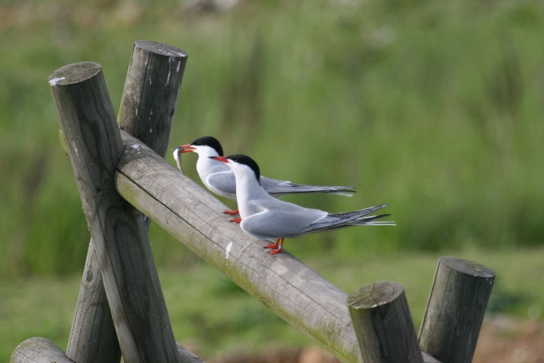
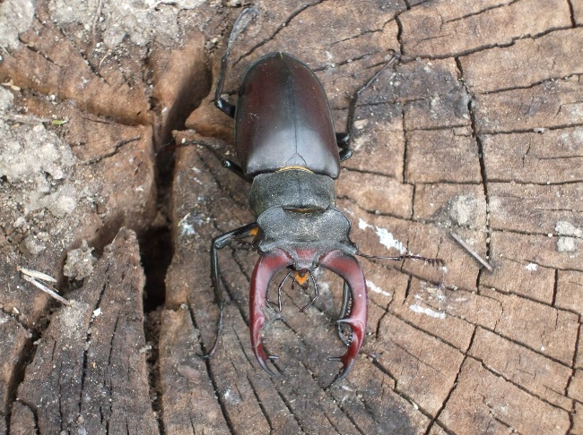

Left: Greater Stag Beetle Right: Common Tern

There are other BoCC4 Red and Amber List bird species that have visited the park most years, including Fieldfare, Mute Swan, Shelduck, Wigeon, Gadwall, Teal and Common Sandpiper. The lakes continue to support a wide range of water invertebrates, including leeches, mayfly nymphs, dragonfly and damselfly nymphs, caddis fly larvae, saucer bugs, screech beetles, greater and lesser water boatmen, water stick insects, water scorpions and a variety of pond snails. Amphibians recorded are Common or Smooth Newts and Common Frogs. Common Toads have not been recorded since building work has progressed on the fields surrounding the park.

2.6.3 Rights of way

- There are no statutory bridleways or footpaths within the site. All access paths are permissive and therefore access can be controlled.

2.6.4 Planning designations

- From the time of the Millennium Village competition, it had always been envisaged that there would be an ecology park within GMV – and the park formed part of the GMVL competition submission. The ecology and southern parks, essentially as built, were part of the outline and relevant detailed planning consents.

- The Ecology Park has been designated a dog free zone by the Royal Borough of Greenwich

2.6.5 Byelaws, covenants, leases, easements

- There are no Byelaws in place for any part of the Greenwich Peninsula. The HCA did look at the possibility of introducing byelaws some years ago (to control dog fouling, litter etc in parks and other public areas). LGB would have been responsible for enforcing any byelaws but it was found that LBG had few, if any, byelaws themselves – and did not have the staff to enforce byelaws.

- The developed land surrounding the southern and ecology parks was leased by EP (now HCA) to GMVL on long-term (999 year) leases. There is also an Agreement to Lease in place for the future GMV phases on the other sides of the parks.

- There are no easements or rights of way in the vicinity of the ecology and southern parks except for the Thames Path that runs between the ecology park and the river; this is a public highway (for pedestrians). This same path is also used by maintenance vehicles and may at times be used on an informal basis by the ecology park staff for vehicles making deliveries and for disabled parking.

- There is an easement established in favour of LT for the pumping main that brings the water supply to the park from the borehole. NB a new borehole is due to be added nearer to the Ecology Park in 2017.

2.6.6 Peninsula development

Greenwich Peninsula, covering 190 acres, is one of the UK’s largest regeneration projects creating a new district for London including homes, offices, schools, shops, improved transport and community facilities, as well as opening up access to the river. It was promised to be a “modern urban community in the curve of the Thames with space to breathe, space to think and space to build” and Greenwich Peninsula Ecology Park plays a key role in delivering on this promise.

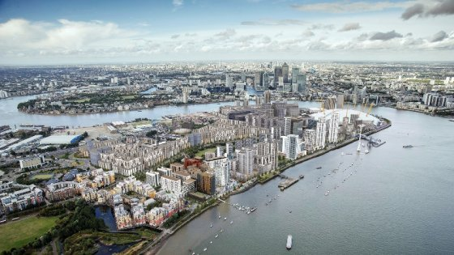
Development of the surrounding area has gathered pace since the last site management plan. Links are already being forged with developers on the Peninsula to share information, to try and create a stronger ecological network with other greenspaces and to promote the Ecology Park as one of the key benefits of the area, as well as garnering potential financial support for the park.
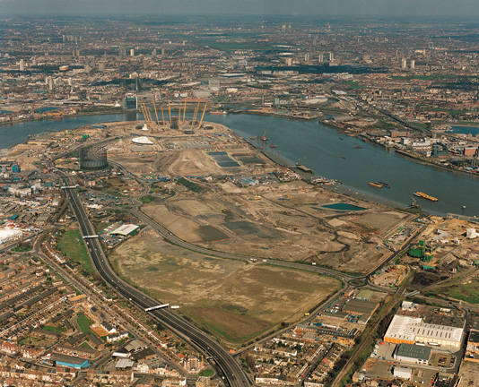

Current developers on the Peninsula are:
- Greenwich Millennium Village or GMV - a joint venture between Countryside and Taylor Wimpey - which develops the land around the Ecology Park.
  - Much of this has already been built. The last phases of development are along Pear Tree Way and West Parkside and will include a nursery and community centre as part of planning conditions.
  - The buildings along the back of Pear Tree Way and next to the aggregates works are taller than originally planned (13 stories) due to newer acoustic regulations.
  - GMV development consortium has outline planning permission for a phase of development that includes a tall block very close to the Ecology Park which will shade the park at key times.
- Knight Dragon - Hong Kong based developer controlled by billionaire Dr Henry Cheng - which is developing the rest of the Peninsula.
  - The new 2015 masterplan changed the focus of development from business to residential due to competition with other business districts in London. This translates to an increase from about 10k residential units to 15 ½ k and an increase in the height of buildings to make this happen. There will eventually be 35,000 residents in the Knight Dragon development area
  - This extra housing requires more open space so Central Park will increase in size by moving West Parkside westwards.
  - A design district near the O2 which will include an extension to Ravensbourne and a digital hub – digital office space for smaller businesses. A media complex for film and media productions, the size of Neasden studios, is proposed for the area next to central Park.
  - Meridian Quays on the west side will face Canary Wharf and have some form of greenspace within it and by the river, together with a new river jetty. There will be a jetty to jetty walkway from west to east linking the 2 sides of the Peninsula near the O2. There will also be a bridge over Millennium Way and the Blackwall Tunnel approach to facilitate access to other areas of the Peninsula.
  - The bus station is at 95% capacity so a new bus station will be built, increasing bus stands from 11 to 17. North Greenwich will have to be re-built – the Jubilee line capacity is forecast to increase by 20%. It is proposed to build over the current tube station so that it can remain open during construction.
  - An energy centre has been constructed on the peninsula to provide local power supplies (using gas)
  - A 5 kilometre running track is currently under construction around the Peninsula and has involved the removal of much of the grass and trees along the riverside walkway.
  - The construction of a through school, from primary to secondary, has been completed and is now open on the Peninsula (St Mary Magdalene). This is in addition to the existing Millennium Primary School.

2.6.7 Impact of development on the Ecology Park

Future development of the peninsula will bring both opportunities and present real challenges for Greenwich Peninsula Ecology Park that will have to be taken into consideration over the next 10 years. The extension of Central Park is welcome if wildlife interest can be incorporated into the landscaping. The issues below are of current concern:
- The substantial increase in resident numbers on the Peninsula with, as yet, few community facilities – this will put extra pressure on the park’s resources.
- The potential 13 storey building close to the Ecology Park as part of GMV which will shade the Ecology park and affect habitats, wildlife and people’s enjoyment of the park
- The Peninsula now has 2 large primary schools and a secondary school. The park’s education programme is already at full capacity with the current resources available and may not be able to fully engage with local schools
- The current lack of integration between the two parts of the Peninsula that different developers control. This affects integration of greenspaces, pedestrian routes and cycle paths as well as other issues, e.g. Knight Dragon see the Ecology Park as part of the GMV development rather than a Peninsula asset and so do not currently consider potential financial support.

2.7 Management considerations and constraints

The following paragraphs summarise existing management issues identified within the site.

2.7.1 Security and access

- Security and lone working has become less of an issue since the area has become more developed and volunteer wardens have been recruited to help on site at weekends,
- The CCTV system has been updated and upgraded. Security will need to be monitored as the Peninsula area develops and the area becomes busier.
- Police do patrol the Peninsula, mainly in the O2 area, but this has reduced significantly due to cuts to the local/community police and the increase in area for individual police to patrol. The park wardens have a good relationship with the local Safer Neighbourhoods Team.
- There are some problems with people fishing and accessing the inner park after hours in the warmer months. Regular de-fishing of the outer lake will deter illegal fishing.

2.7.2 Current building

- The new outdoor classroom has provided much needed extra space for events, education, etc and this puts less strain on the gatehouse which is also the entrance to the inner park. The Gatehouse is in need of refurbishment and funding will need to be sourced to fund this.
- The cabin toilets and drainage system are of a basic standard.
- There is good disabled access across the site but not to the kitchen and office space, which impacts on disabled volunteer access.

2.7.3 Increased use of the park

- Since opening in February 2002, the Park has attracted an average of 10 to 12k visitors a year. This has gradually increased as the surrounding area has developed and as the park has become better known. A daily record is kept of estimated visitor numbers, recorded in the site diary and summarised in an annual report. More accurate recording of visitor numbers will be addressed during the course of this plan. The impact of visitors is assessed by the Park wardens and managed by various means:
  - Recruitment of volunteer weekend urban rangers to help manage the park at weekends and be available to talk to visitors
  - Provision of educational activities, such as quiz trails for children and families, pond dipping days in school holidays, regular events and drop in art activities in the Gatehouse.
  - Use of temporary information signs around the site to guide behaviour, including increased use of pictorial signs to reach people with little English or ESOL
  - Development of the Urban Wildlife Code leaflets and posters, devised by the park wardens and originally funded by a grant
  - Confronting inappropriate or damaging behaviour if safe and appropriate
- More staff on site will be needed to cope with the extra demand on the park’s services. Funding is currently being sought for a further full time member of staff to assist with education, events and outreach.
- Part of the site along the main shingle beach has no public access, although wardens and volunteers use this area for surveys and to gain access to the compost heaps. It will be vital to maintain this area as strictly limited access. Screening will also need to be maintained where currently present alongside the boardwalks. Optional closure of areas of boardwalk should also be considered if necessary and appropriate. This may include closure during nesting time, where problems occur e.g. with swan nests near the edge of the boardwalk, although this will be difficult to police out of hours on the outer boardwalk.

2.7.4 Anti-social behaviour

- From experience gained in managing the site since opening in 2002, activities of concern include fishing, bird feeding, dropping litter, throwing rocks and other objects into the water and at the wildlife, stealing or damaging bird’s eggs, noise disturbance and use of scooters, going off the boardwalk into the habitats, picking plants and flowers.
- This is currently managed in similar ways to managing visitor numbers as above: by providing alternative activities e.g. quiz trails and use of binoculars instead of bird feeding; by use of temporary information signs – politely but firmly asking people to deter from certain activities and, importantly, explaining why; by confronting behaviour if safe and appropriate to do so. More recently, graffiti has become more of a problem across the Peninsula. Greenwich Council contractors currently remove graffiti from the outside walls of the park.
- Abusive behaviour and damage to bird’s nest and eggs is always referred on to the appropriate authorities and the RSPCA. Liaison with local community police has since helped but does not provide immediate back up. The outer lake is due to be de-fished - to maintain to deter fishing as well as maintain biodiversity.
- Anti-social behaviour has increased slightly as the surrounding area has developed. This has not been helped by fewer and less frequent police patrols and cuts to the local Safer Neighbourhood Team. Social landlords on the Peninsula are also less proactive with community work than at the start of the development. Community outreach and education will be even more important as the Peninsula develops further.

2.8 Ecological considerations

2.8.1 Reedbed growth

- Management of reedbeds will require monitoring to inform the period of rotational cutting. Different areas of reedbed are currently cut each year in autumn, preventing excessive spread across the lakes whilst maintaining a good structure and range of growth stages for different animals, e.g. the Wainscot Moth caterpillar that requires older reed stems of a certain thickness in which to grow and pupate, Reed Warblers that prefer 2 year old reed growth in which to nest. Some areas are cut annually where they block views across from the bird hides or where they reeds are particularly invasive and affect the growth of other marsh vegetation (e.g. outer lake inlet).

2.8.2 Sensitive areas - access and disturbance.

- The main shingle beach remains inaccessible to the public but is used by wardens and volunteers for surveys and access to the compost heaps. The original woven willow fence panels have been replaced along the length of the inner lake boardwalk. Other temporary fencing is considered where appropriate to protect vulnerable areas and nesting birds.

2.8.3 Colonisation by new and/or alien species, especially in shingle beach and open water habitats.

- Willow Emerald Damselflies were first recorded in the park in summer 2018. This species is a recent colonist to the UK and lays eggs on the branches of willow and alder that overhang the lakes. The British Dragonfly Society are tracking this species in order to understand how it is spreading so rapidly and what might limit the species in the future.
- American or Least Duckweed has been accidentally introduced into the inner lake but is currently restricted to 2 corners of the lake. This is regularly fished out and is not presenting a problem at the moment.
- Azolla, accidentally introduced into the inner lake, was successfully treated with a biological control (a weevil). This is continually monitored. Azolla is still present but microscope surveys of the lake invertebrates showed that the weevils (that eat the Azolla) are also still present.
- Buddleia self-seeds from the river beach and is cut back or removed before it can become a problem by out shading hedgerow shrubs and plants on shingle habitats or by growing out from walls and causing damage
- Goat’s Rue, a naturalised Mediterranean plant that is commonly included in meadow seed collections, has become an increasing problem in the meadow and shingle areas where it grows taller and shades out other meadow plants. It is regularly dug out or cut back before seeding.
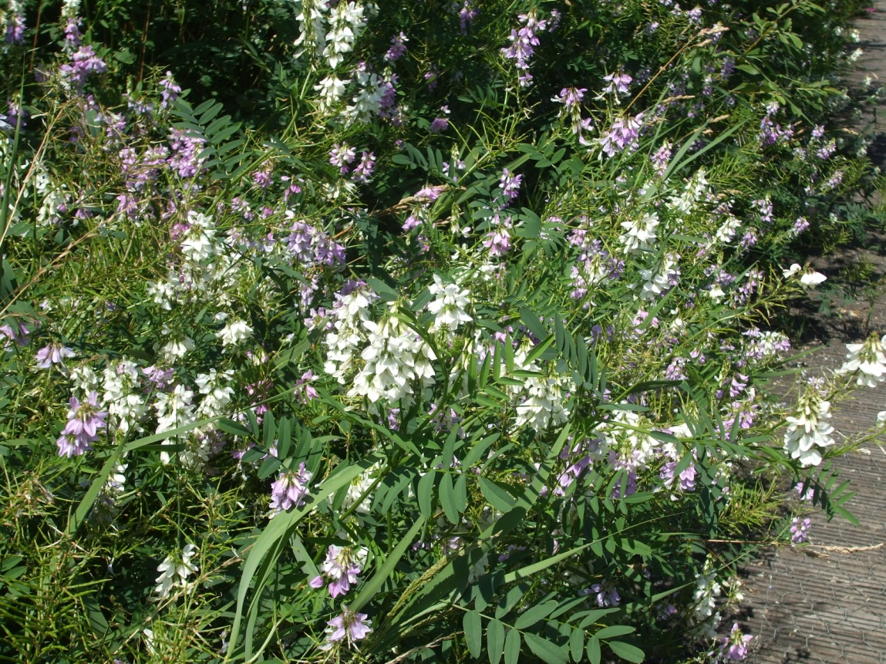
Goat’s Rue in meadow

2.8.4 Prevention of succession and maintenance of a mosaic of habitats.

- Shingle beach is a pioneer habitat that needs extensive management to maintain as open shingle, free from scrub and grass encroachment. A natural beach would be cleared, or excessive plant growth reduced, by the actions of wind, salt, water or grazing but here at the Park it relies on extensive manual effort. Clearing the shingle beach each year is one of the most labour intensive tasks of the habitat management but is successful in maintaining the habitat and its associated flora. The smaller shingle beach between the hides is flatter and wetter so has more of a problem with grass species. Yellow Rattle has been seeded onto this area to help prevent rapid spread of grasses. Each year different areas of the beach are completely cleared and other areas cleared only of problem species and this has proved very effective in maintaining the area as a pioneer habitat whilst allowing important biennials such as Viper’s Bugloss to thrive and areas of low growing plants such as Bird’s-foot Trefoil to develop.
- In the marsh and reedbed habitats, tree and hedge species are increasingly self-seeding and these need removing annually.
- Alder trees also increasingly self-seed all over the inner park but especially on the sandy banks of the outer lake in the inner park. Theses need removing on a more regular basis throughout the year before they become too large and established. Some alders have been allowed to grow on as standards among the willow beds in the inner park. Cutting accessible marsh and reed areas on a biennial basis and clearing away cut vegetation prevents the build-up of too much dry material and halts succession to scrub.
- A small area at the end of the shingle beach has been fenced off as a “wilderness” area, where bramble and gorse are allowed to grow freely, as a habitat for birds and butterflies

2.8.5 Bramble management as site matures.

- Bramble is allowed to grow on in some small areas of marsh and woodland, as cover for birds and other animals, but is strictly controlled elsewhere. It has become invasive in parts of the shingle beach meadow, marsh and woodland and needs regular cutting back and pulling out. In the woodland, it tends to stifle growth of other plants such as Common Dog Violet if not cut back. Note that cut ends of bramble stems are important for some of the park’s solitary bee species

2.8.6 Sediment accumulation in lakes and ponds.

- It was originally planned to have a full clean out if required approximately once every 10 years and de-silting to be carried out piecemeal once every 3 to 4 years. The full clean out is not recommended as it would be highly disruptive. Instead, problem areas of build-up should be identified and substrate removed on a smaller scale at more regular intervals (each year when carrying out work on the lakes and reedbeds).

2.8.7 Maintenance of compost area.

- Compost is an issue as there was originally no area allocated for this. A huge amount of cuttings from the marsh and meadows need to be stored each year and it is very slow to rot. 6 wooden compost bins were added to the top of the shingle beach alongside the hedgerow in 2007 and this has helped contain some of the material. A large compost heap remains but is now turned at least once a year by volunteers.
- Cut reeds are stored in a pyramid of tied bundles each year and used to make fencing and huts in the education meadow. Bramble and woody materials are burned on the river beach (with permission) at regular intervals. Various methods have been tried to accelerate the decomposition process of other materials.

2.8.8 Tree growth and coppice rotation.

- A system of coppice rotation has been developed over the years to maintain different areas of willow growth around the site.
- This is important to provide a range of coppice habitat at different stages of growth whilst maintaining screening for other habitats. It has also helped to produce new coppice growth with much straighter stems which can be used more effectively for fencing and weaving. Original growth of Grey Willow tended to be non-uniform and not usable when cut, so each year more areas of Grey have been targeted.
- Different species grow at very different rates and the Osier needs coppicing every 1 to 3 years, while other species can be left to grow on for longer once originally coppiced to obtain straighter growth.
- Each winter, some areas have been completely clear coppiced while others have been left or selectively coppiced where willow growth shades meadow area or grows over boardwalks.
- Some willows have been left to grow on as standards or pollarded to provide a greater range of habitats for birds. Other tree species, including alder, have also been left to grow as standards in willow beds.
- The alder carr has been thinned since its original planting and may require further thinning as it matures. Monitoring for signs of disease is also required. Strong winds have felled several weaker alders. A tree safety check is carried out in the carr on a weekly basis. The alders also tend to shed many branches and smaller twigs in windy weather.

2.8.9 Brash clearance / disposal after coppicing.

- This was a problem in the early days of the park as there is no space for storage of brash without affecting other habitats. This was resolved by the collection of brash in one area and hiring a tree surgeon to chip it all in one go at the end of the coppice season. The resulting woodchip is then spread around some of the coppiced area as mulch .
- In recent years, brash has also been used for dead hedging which has helped screen existing habitats and provide extra habitat at a time of increasing development around the park
- Fencing poles are prepared and stored in the ephemeral pool area until used for fencing and willow structures in the Park or in school and community gardens.

SECTION 3: AIMS AND OBJECTIVES

The following aims and objectives set out a framework for the management and development of the site, addressing environmental, social and economic issues. These aims and objectives will provide the basis for the development of specific management operations throughout the site and reflect the multi-use benefits that could be achieved. Many of the aims and objectives are cross-cutting; actions within the operation plan will meet a number of different aims and objectives.

The aims and objectives set out the aspirations for the site. However, it must be recognised that these need to be balanced with practical considerations. Although the intention is to seek additional funding, there will inevitably be financial and other constraints on what is achievable. There will also be inevitable conflicts between objectives, for example between access and conservation, which will need to be addressed over time. Expectations as to what can be delivered must be tempered by what is practicable, affordable and sustainable.

The following key Aims tie in with the Core Aims of the Land Trust, which in turn tie in with the core aims of TCV. The Trust measures its performance against a set key performance indicators tied in with its core charitable aims.

AIM 1 (ENVIRONMENTAL CORE AIM)

To develop and maintain all habitats to their prescribed extents and locations as set out in the detailed design drawings, so as to achieve all intended amenity, mitigation and wildlife functions.

MANAGEMENT OBJECTIVES

- The water levels on site must not cause any flooding and/or negatively impact on any surrounding residential or industrial landholding, buildings or transport infrastructure.
- Within water bodies, reed beds, wetlands and ditches the maintenance of open water channels and provision of dense stands of emergent plants, tall herbs and wet grasslands are important for both ecological and hydrological purposes, in that they support a diverse and healthy population of small mammals, amphibians, insects and waterfowl. The management of the network of water bodies will focus primarily on maximising the nature conservation potential of its component features.
- The management of marginal vegetation should ensure that water bodies retain their aesthetic function within the landscape, whilst also enhancing species diversity and value of wildlife habitats.
- Conservation grassland swards are important in providing valuable wildlife habitats for insects, invertebrates, small mammals and birds. Whilst conserving wildlife habitat, the management of this grassland must ensure that species diversity is enhanced in the long-term and that ruderal species are not permitted to compromise the integrity of the grassland composition.
- The walk-in meadow adjacent to the interpretative sign should be maintained as an educational resource as well as a wildlife habitat, including habitat features therein.
- The shingle beach habitats are one of the most varied and fascinating in the Ecology Park. They should be maintained as pioneer habitat for invertebrates and annual and biennial plants. Further erosion of the spit should be prevented and the water channel between the spit and shoreline maintained. The pebbly area around the ephemeral pool should also be maintained for natural colonisation by annual plants.
- Smaller ponds and pools should be maintained as healthy habitats for aquatic plants, invertebrates, amphibians, and passerine birds.
- Willow beds should be maintained by coppice rotation to achieve good wildlife habitat and required shelter and screening functions, as well as to manage their size.
- The hedgerow is to be maintained as a distinct habitat as well as a means to deter entry to the Ecology Park other than via the gatehouse.
- The Carr woodland should be allowed to mature into a habitat dominated by alder, sallow and birch trees, with shrubs such as guelder rose, buckthorn, dog rose and brambles. However, trees will need to be closely monitored due to their proximity to buildings and public paths. Diseased, dead and dangerous trees will need to be felled where they pose a risk to the public. The wet meadow glade areas and streams should be maintained and cleared as necessary.
- Artificial refuges for wildlife should be maintained as appropriate but may be subject to review, replacement or enhancement according to use. This includes the tern rafts, bat tower, nesting and bat boxes, standing deadwood and log piles.
- Vegetation should be protected against excessive damage from waterfowl, especially Canada Geese, when needed.

AIM 2 (ENVIRONMENTAL CORE AIM)

To maintain water quality in the lakes to meet aesthetic and ecological requirements.

MANAGEMENT OBJECTIVES

- Water quality will be monitored by daily visual checks and regular aquatic invertebrate and plant surveys. De-fishing should be carried out as appropriate to maintain water quality and diversity of aquatic invertebrate life.
- Water circulation systems and diffusers in the lakes will be used as required to maintain water quality, when in full working order.
- The health of aquatic and emergent plants will be monitored and replaced if necessary to assist in water quality maintenance.
- Reed-beds will be managed appropriately to assist with water quality maintenance, especially since the loss of some recirculation flows.
- The quality of top-up borehole water should be regularly monitored.
- In case of failure of the borehole source, in conjunction with drought, other water sources should be considered and employed, e.g. mains water, undertaking any necessary pre-treatment and dosing.
- Where reed and marsh vegetation is carried out, some substrate should be removed to prevent excess build up of sediment in some areas of the lakes.
- Algae growth in summer should be monitored and barley straw bales used as appropriate to deter algal spread.
- The lakes should be regularly monitored for Azolla and the lakes treated to remove it where necessary.
- The lakes should be regularly monitored for American or Least Duckweed and steps taken to prevent its spread where necessary.

AIM 3 (ENVIRONMENTAL CORE AIM)

To maintain target water levels in the two lakes within the prescribed limits to benefit human amenity and to promote wildlife value. Note: this is a LT / contractor responsibility.

MANAGEMENT OBJECTIVES

- Maintenance of outer lake level at 5.6m AOD (Above Ordnance Data)
- Maintenance of inner lake level normally between maximum height of 5.5m AOD and full exposure of edge substrate but not below 5.0m AOD. In a normal year, the lake should be allowed to draw down gradually from around April to a point at which the edge substrate is fully exposed. This level should be maintained until September; at which point a gradual top up in level to 75% of maximum by October and maximum by November should be applied. In a drought year, extra summer top ups may be required to maintain water quality.
- All water pumping and circulation equipment should be maintained in good working order.

AIM 4 (ENVIRONMENTAL CORE AIM)

To minimise human disturbance to wildlife and habitats as far as possible, whilst promoting controlled public access to the ecology park and free public access to the rest of the Village Marsh.

MANAGEMENT OBJECTIVES

- Visitor use of the Ecology Park should be monitored and regulated as appropriate.
- Barriers to unauthorised access and screens between people and wildlife should be conserved and maintained.
- Bird feeding with bread should be discouraged and alternative activities provided for visitors

AIM 5 (EDUCATIONAL, COMMUNITY COHESION, ENVIRONMENT & HEALTH CORE AIM)

To promote and protect the long term amenity including aesthetic, recreational, educational and research benefit for the visiting public, and neighbouring residents.

MANAGEMENT OBJECTIVES

- Litter should be removed regularly
- Any features subject to vandalism/graffiti should be repaired promptly and appropriate measures taken to reduce the risk of further vandalism.
- Boardwalks, hides and lighting should be maintained by contractors but any defects reported by the managing agent immediately
- Educational boards and displays should be maintained and update as appropriate.
- Visitor use and attitudes should be monitored and feedback obtained where possible.
- Links with interested parties should be maintained and strengthened.
- Educational and promotional events and activities should be organised seasonally and in school holidays according to resources available .
- Promotional material should be provided including a site leaflet and posters for events.
- Regular education tours and sessions for local Primary and Secondary schools will be offered at least for the key spring and summer seasons

AIM 6 (MANAGEMENT AIM)

To promote public safety at all times.

MANAGEMENT OBJECTIVES

- A site risk assessment will be carried out annually and regular weekly checks undertaken in accordance with the details supplied in the management agreement.
- A weekly tree safety check will be carried out by the site wardens
- Risk assessments and COSHH assessments will be carried out for all tasks and activities on site by the site wardens.
- Lighting will be maintained in functional order (LT appointed contractor )
- Wardens will be trained in first aid and a full first aid kit available in the gatehouse.
- Compliance with all relevant health and safety legislation.

AIM 7 (ENVIRONMENTAL, EDUCATION & ECONOMY CORE AIMS )

To undertake monitoring, survey and research and the keeping of environmental and biological records in order to facilitate the achievement of other management objectives.

MANAGEMENT OBJECTIVES

- The extent and health of all habitats should be monitored on an ongoing basis for the fulfilment of regular management tasks.
- Where resources and time allow, the colonisation and use of the Peninsula by birds, plants, terrestrial and aquatic invertebrates, amphibians, small mammals and fish should be monitored and recorded. This will be undertaken by staff and volunteers with more detailed surveys by outside experts when funds allow. Data should be sent to GiGL.
- A series of photos at set points in the Ecology Park should be taken quarterly as in past years.

AIM 8 (SOCIAL COHESION, LOCAL EMPLOYMENT & HEALTH CORE AIMS)

To put in place and maintain an effective and progressive system of management that involves local people and interested organisations in appropriate ways and promotes integration with other open space on the peninsula.

MANAGEMENT OBJECTIVES

- The management of the Park should be reviewed in the light of monitoring and management requirements elsewhere on the Peninsula where this enhances biodiversity and/or community engagement. Positive connections with developers should be maintained.
- All possible opportunities for fundraising will be explored by the TCV and the Land Trust, as well as the Friends group.
- Regular meetings of the established Friends of the Ecology Park group should be encouraged to support and fundraise for the work of the park.
- A series of seasonal events, drop in activities for families and environmental play activities will be organised in the school summer holidays, the extent and range dependent on funding and resources
- Corporate workdays should be organised in liaison with TCV and the Land Trust to involve local and London businesses in the practical habitat management work of the Park
- A range of volunteering opportunities at the Park for local people will be organised and promoted, including a regular weekly practical conservation workday .

AIM 9 (MANAGEMENT AIM)

To manage the site in a cost effective manner and to maximise income generating potential to reduce management costs without negatively impacting on other Site Core Aims & activities.

MANAGEMENT OBJECTIVES

- Potential revenue sources should be identified by TCV and the Land Trust
- Income via sponsorship should be encouraged where appropriate
- Revenue grant funding will be sought for projects and activities on site
- See also Vision section of this document for future plans.

SECTION 4: VISION UPDATE
This section sets out a vision created for the 5 to 10 years for the Ecology Park from 2017, as the Peninsula development gains pace around it. It was developed by TCV and the Land Trust and reflects the need for more resources and community space as more people live, work, go to school and enjoy leisure time on the Peninsula, whilst maintaining the Ecology Park as a high quality nature reserve. High quality land management for wildlife and people provides an exciting resource for all those who live, work and play within the Greenwich Peninsula.

4.1 Setting the Vision

Greenwich Peninsula Ecology Park is a tranquil oasis for people to discover and enjoy a fascinating variety of wildlife in the middle of an increasingly developing urban area. The park is a green hub for the community and a place that allows wildlife to thrive and people to connect. Environmentally based activities provide many opportunities for meeting the challenges of education, community involvement, social inclusion, public health, skills development and lifelong learning.
By 2020, the aim is to establish:

- A site that is in at least as good or better ecological condition and that allows a diverse set of habitats and wildlife to not just survive but thrive
- A site that can accommodate an expanded range of activities for children and adults within a comfortable environment without taking away from the already limited natural/green space
- A site that is appropriately resourced to deliver exceptional visitor and volunteer experiences
- A site better ecologically linked to the other green spaces on the peninsula and the Thames River
- A green hub – designed around the needs of the local community and environment and acting as a focal point for the care of local green places

4.2 Achieving the Vision

There are many things that will need to be done to achieve this vision – they range from smaller projects to much more complex initiatives requiring more significant investment and resources. We recognize that it is not realistic to do everything immediately so the activities below have been broken down into short to medium term and longer term projects and also grouped into categories by the type of project.

Short to Medium Term (2017-2020)

- Site Enhancement Capital project: Relocation of the borehole closer to the Ecology Park - completed in 2018
- Site Enhancement Capital project: Additional water run-off system from new phase of GMV development funded by GMV development consortium – completed in autumn 2017.

- Site Enhancement Capital project: New wooden interpretation structure costing up to £20k to replace the original metal interpretation boards in the centre of the park by the walk-in meadow. Planning permission has been granted and designs drawn up by architects. Funding is now being sought to progress.
  - The structure will have a second storey accessed by steps to a viewing platform over the site. The lower structure will provide covered space for education sessions and will provide interpretation as well as extra habitat boxes and features.
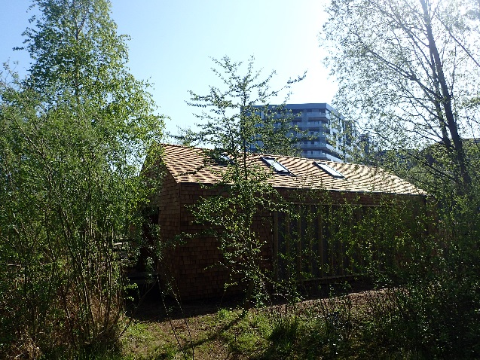
- Site Enhancement Capital project: New wooden education building costing up to £200K to address the need for extra education and workshop space and the potential for income generation – completed in spring 2018
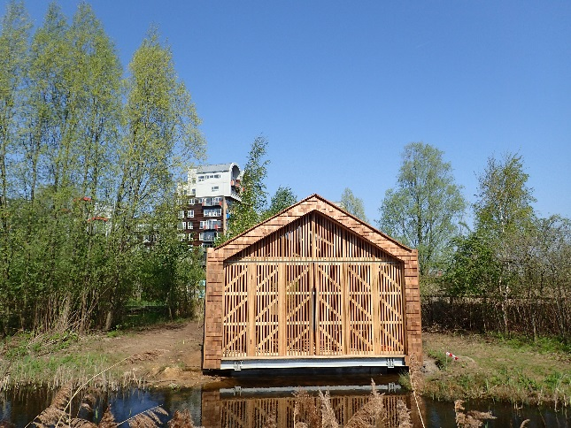
- Education/Community Engagement Revenue project: Part time or full time education/outreach worker. Funding currently being sought.
  - This post will help extend educational provision and develop outreach projects

Longer Term (2020 - 2025)

- Site Enhancement Capital project: Complete replacement of current Visitor Centre with new purpose- built sustainable ecology centre
  - To address the need for an up to date, fully accessible, purpose-built visitor and community centre – an ecology centre for an ecology park. This could include interpretation and visitor facilities including cafe and shop, community and workshop space available for hire, better office and welfare facilities for staff and volunteers.
  - A major fundraising bid or major corporate support would be needed for the longer term re-build, including feasibility study, community consultation etc. We would also need to plan for keeping the park open while the facilities are removed and rebuilt.
  - In the interim, a gatehouse upgrade is being planned and costed in 2018, addressing the needs for better heating, insulation and visitor facilities.
- Education/Community Engagement Revenue project: Extra Project Officer/Warden
  - This post will help extend services so that there will eventually be a Site Manager, 2 wardens or Project Officers and an Education/Outreach Warden

SECTION 5: OPERATIONS PLAN

5.1 Habitat management operations

Specific habitat management prescriptions are detailed in the following text. The site is divided into habitat types and sub compartments and these are shown in the maps in Appendix 1. An annual Habitat Action Plan is also drawn up each year by the site wardens (see sample in Appendix 2).

5.1.1 Reedbeds and marsh (including marginal vegetation)

- Maintain and control reed beds and marsh through rotational cutting to retain sufficient open water, structure and plant diversity in marsh areas. The period and timing of rotation will be dictated by condition monitoring, location of reed beds and wildlife needs. Reeds in front of the bird hides will need an annual cut. Some marsh areas (i.e. not reed beds) need an annual cut to prevent reed dominating and shading out other plants such as Flowering Rush.
- Dig out roots of reeds and Greater Reedmace where encroaching across narrower areas of the lakes.
- Keep outer lake inlet channel free of vegetation by annual cut and digging out as necessary to maintain water flow
- Remove encroaching bramble and self-seeded tree species from reed and marsh areas.
- When cutting marsh areas, remove dead vegetation and litter on the ground to prevent reed beds drying out and loss of habitat through natural succession. Remove cuttings from the managed area.
- When cutting back marginal vegetation, remove silt build up from the lake in the same area, allowing invertebrates to return to the water by placing dredging at the lake edge first.

5.1.2 Grassland

- Cut vegetation to ground level in the autumn and remove all cuttings to the compost area. Leave areas of uncut vegetation as an invertebrate and amphibian refuge. Leave larger uncut areas along the shore of the inner lake and between the two bird hides as winter bird habitats.
- Monitor problem species and thin or weed out as required, particularly Goat’s Rue. Regularly remove encroaching bramble and self-seeded tree species.
- Maintain the habitat features in the walk-in meadow, which currently include log piles, minibeast towers, a small pond, reed den and woven willow structures
- Maintain the cockleshell path through the shingle beach meadow area by weeding and replacement of shells as necessary to prevent trampling of the meadow when accessing the area for surveys and habitat management work.

5.1.3 Open Water

- Monitor water quality by appearance and by results of regular pond dipping sessions with schools and groups.
- Use aerators and water circulation systems, when working, as appropriate to maintain water movement, prevent stagnation and maintain water quality.
- Add barley straw bundles to the inner lake in early spring to prevent algae growth. Monitor both lakes for algae growth and treat as necessary – this may include Symbio treatment in bad years.
- Organise de-fishing of the lakes when necessary to reduce fish numbers and remove non-native fish, especially in the outer lake.
- Top up outer lake regularly all year round to maintain level at 5.6m AOD (Above Ordnance Data)
- Gradually top up inner lake up to 75% maximum by October and up to maximum level by November (max level is 5.5m AOD). Allow level to naturally lower over spring and summer to expose mud banks but top up slightly in drought conditions or where water quality is affected.

5.1.4 Wet woodland/carr

- Carry out weekly tree checks to identify weak, diseased, dead or dangerous trees and branches
- Remove dead, diseased and potentially dangerous trees but retain some standing deadwood where safe to do so.
- Review annually and thin alder carr woodland as necessary to allow larger trees and other tree species to grow on.
- Cut the woodland glade area in the carr annually and remove cuttings to compost area within carr
- Control bramble spread in the carr to allow wildflower bulbs and meadow areas to thrive. Maintain some areas of bramble thicket away from public paths to provide more nesting habitats for birds.
- Manage the willow beds in the inner park on a coppice rotation basis according to species, rate of growth, proximity to paths, screening and wildlife needs. Coppice selected areas of willow bed in the inner park on an annual basis from December to February. Allow some standard trees to grow on within coppiced areas where appropriate.
- Prepare and separate coppice arisings into poles and brash, the poles being used on and off site for fencing and weaving. Brash should be chipped annually and used as mulch or used to make dead hedging where appropriate.
- Control bramble growth in coppiced areas to allow other plants to flourish.

5.1.5 Hedgerow

- Monitor for Brown-tailed Moth caterpillars (these haven’t been a problem in recent years)
- Review growth of hedgerow as it matures and lay section and/or prune tops to encourage bushier growth. Coppice willow within hedgerow when necessary whilst retaining cover to deter access (use temporary fencing if needed). Remove self-seeded buddleia. Prune back branches growing out over adjacent shingle areas.
- Remove litter from hedgerow regularly, especially at far end where rubbish is thrown over site fence

5.1.6 Shingle beach

- Completely clear large areas of the main shingle beach each year in autumn and winter by weeding and digging over. Rotate these areas each year so that some areas are left for important biennials such as Viper’s Bugloss each year. Weed problem plant species from the remaining areas – bramble, buddleia and plants such as Lucerne and Goat’s Rue.
- Remove self-seeding alders from the shingle edges of the outer lake and the spit in the inner lake each year.
- Clear the small shingle beach cleared annually in the autumn. Monitor invasive grasses and add Yellow Rattle seeds in the autumn to weaken grass growth.

5.1.7 Compost and waste materials

- Turn over compost in wooden bins and main heap at least once a year. Sieve and bag up usable soil to use off site.
- Chop up vegetation before adding to compost heap or bins
- Collect bramble, bindweed and woody vegetation separately and periodically burn on the river beach at low tide (following fire safety protocols)

5.1.8 Artificial refuges

- Inspect and clean bird boxes annually in January
- Review use of bat tower with bat conservation groups
- Maintain and repair minibeast hotels and bee boxes – add extra as appropriate
- Maintain deadwood area and continue to replace part buried, standing deadwood structures as they rot down.
- Clear and clean tern rafts annually in early spring ( before terns return), replace gravel and re-position in lakes. Inspect rafts and replace as necessary. Maintain shelters on rafts.
- Maintain beehive and surrounding area in liaison with beekeepers

5.1.9 Redundant top up and recirculation beds

- Cut grass as needed in top up grass channels along top of shingle beach near hedgerow
- Maintain top up bed at far end of shingle beach as gravel area with annual plants by weeding annually in autumn/winter and removing bramble. Keep area around bee hive clear at all times.
- Maintain recirculation bed as shingle habitat, removing bramble each autumn/winter. Reduce grass clumps where becoming dominant.
- Monitor water quality in deep pool at end of recirculation bed while water flow is not operational. Remove or treat excess algae growth in summer if needed. Thin out aquatic vegetation as needed to maintain some areas of open water.

5.2 Access and community operations

5.2.1 Access tracks, paths and hard standing

- Maintain all access tracks, paths and areas of hard standing to minimise dilapidation, clear encroaching vegetation and the subsequent threat of hazards. Ensure that litter and other extraneous material is swiftly removed from all areas of formal public access.
- Sweep leaves and twigs from boardwalks regularly in autumn and cut back overhanging branches as necessary
- Do not use chemical treatments or salted grit on boardwalks
- Weed out excess moss between ridges of the wooden boardwalks
- Maintain anti slip matting and wire mesh where needed
- Regularly inspect fencing located around site perimeters and repair promptly
- Maintain and plan replacement of site furniture and information panels as appropriate.
- TCV will contact LT promptly and advise of any issues with repairs or replacements of hard standing. Any item considered to be unsafe will be removed or made safe and replaced as soon as possible.
- Organise regular litter picks of the park and perimeter. Fly tipping is unlikely to occur due to the difficulty of third party vehicular access although will be removed as quickly as possible after it appears.
- Replace or clean any damage caused by vandalism quickly. If items are vandalised repeatedly, make an assessment regarding their replacement.

5.2.2 Capital Replacement

- Minor repairs to fences, boardwalks, seating areas, structures, signage etc to be undertaken by TCV or the contractors as appropriate as part of routine maintenance works. Capital replacement works to be decided and planned in liaison with LT.

5.2.3 Patrolling

- Patrol the site regularly to monitor use/abuse, to identify any problems that may arise and health and safety issues that need addressing, to talk to visitors and users and to provide a visible site presence – to be carried out by site staff together with trained volunteers.

5.2.4 Community Involvement

- Provide a range of volunteering opportunities for the local community, including habitat management workdays and volunteer ranger and Volunteer Officer schemes
- Facilitate the Friends group meetings and activities
- Organise employee volunteering days

5.2.5 Formal education and training

- Provide an educational service at least 2 days a week on Mondays and Tuesdays during term time in spring and summer terms. Other dates may be offered at other times, especially early autumn, where staff time allows. This service will be charged to provide income for the site.
- Keep up to date with national curriculum requirements
- Keep records of education visits and curriculum topics covered. Collect feedback from teachers.
- Recruit a Volunteer Officer to assist with education visits each year.
- Continue to offer work experience placements to Greenwich and Lewisham secondary schools and to University of Greenwich teacher training students
- Liaise with LT and the Friends on the new education building project on site and extra education staff member
- Explore the site’s potential for training purposes when the education building project is underway. This may range from opportunities for students with a professional interest in environmental management to general skills.

5.2.6 Informal Education:

- Organise seasonal events and school holiday activities according to resources available. At present, these include Frog Day, Wild Day Out, Dawn Chorus, Pond Dipping and Bug Hunting Days and a Winter Fayre, plus extra summer events in July and August.
- Continue to offer guided tours and activities for community groups
- Continue to provide drop- in activities for visiting families and children, including quiz trails. Maintain educational, play and art resources in the gatehouse in good working order.
- Regularly update and change displays in the gatehouse. Update wildlife sightings boards. Provide Visitor Book for comments and wildlife diary for visitor sightings.
- Continue to offer outreach visits off site where staff time and resources allow

5.3 Management/H&S operations

5.3.1 General management

- LT to comply with the abstraction licence with the Environment Agency
- LT and TCV to conduct an annual review of all site operations, which will include a detailed annual inspection of the site.
- TCV will report any problems or concerns with water management systems as soon as possible to LT.
- Specialist consultants may also be employed where more detailed and specialist support is required to investigate and resolve problems. The intention will be to identify problems early and take the necessary remedial action, thus minimising the potential harm that may be caused if the problem is allowed to develop.

5.3.2 Health and Safety

- The site will be managed to comply with all relevant health and safety legislation, approved codes of practice (ACOPs) and Health and Safety Executive guidance.
- TCV will be responsible for ensuring that risk assessments are undertaken for the site as required under the Management of Health and Safety at Work Regulations 1999 and ACOP (L21), and for monitoring and reviewing the effectiveness of control measures implemented as a result of the risk assessment to ensure their effectiveness.
- TCV will also be responsible for ensuring that accidents and incidents which occur on the site are reported to the relevant enforcing authority as required by the Reporting of Injuries, Disease and Dangerous Occurrences Regulations 1995. TCV must also notify LT in the event of accidents or incidents on site requiring notification to the enforcing authorities.
- LT will retain responsibility for the Health and Safety of the site relating to its historical use and the environmental management as set out above.
- All other aspects of Health and Safety will fall to TCV under normal occupiers liability. A weekly health and safety checklist sheet will be filled out and retained by TCV.
- Health and safety in relation to the waterbodies will follow accepted best practice and TCV’s standard systems following approval from LT.
- The Health and Safety regime for any work undertaken on the site will follow strictly the guidelines as laid down in appropriate HSE publications. As TCV will be the instigator and controller of works on site, TCV will fulfil the landowner’s role and the work manager’s role. This also places an obligation on the LT to ensure that any contractor understands and fulfils their role. The LT will be responsible for operations carried out by LT and its contractors relating to the buildings maintenance and the management and testing / repair of electrical and mechanical equipment.

5.4 Financial and Resources Operations

- Expenditure on physical operations breaks down into the four categories previously defined:
  - Temporary maintenance operations
  - Permanent maintenance operations
  - Capital replacement
  - Additional capital works
Expenditure on these will be strictly controlled by LT and TCV within the budgets available. In general, most expenditure will be incurred by TCV and recharged to LT, although some specialist work, such as environmental management, may be contracted and paid for directly by LT.
- LT will be responsible for managing the overall cash-flow, ensuring that expenditure charged to LT stays within the income generated through the endowment. TCV will be responsible for managing its own cash-flow within the terms of its management agreement with LT and for reporting it on a quarterly basis.
- TCV to work with the Friends group to secure grants and funding (up to £10k) for projects and activities on site, such as the summer holiday activities
- TCV to liaise with LT on larger bids and projects, such as the education building
- In securing additional income, particularly for additional capital works, there would have to be certainty that the site could continue to be maintained within the overall budget.

SECTION 6: MONITORING AND REVIEW

6.1 Site reporting

- Monitoring reports against key measures are submitted to LT on a quarterly basis by TCV, recording ouputs and outcomes, together with financial information.
- LT has developed a range of performance indicators against which to assess the success of individual site and the performance of those managing them and these are integrated into an annual review process. An annual review meeting is held between TCV and LT to review site management operations and performance against agreed targets. An annual report is then produced by TCV, with input from LT, summarising the management of the site over the last year and the outcomes achieved. This is circulated to key partners.
- LT produce a Site Biodiversity Management Statement (SBMS) in conjunction with this plan and from discussions with the appointed managing agent. This serves to identify the key information relating to key species and habitats on site and allows for progress against key targets to be monitored and measured as well as future resource requirements to be identified. The SBMS are periodically reviewed and updated, typically on an annual basis as part or annual review meeting with managing agents.

6.2 Management Plan Review

- This plan will be monitored as an ongoing process by TCV because of the rapid and changing development of the surrounding Peninsula. A careful balance needs to be struck between ensuring that this can take place without it becoming a burden in its own right, which ends up distracting attention and resources from the actual management of the site.
- The plan will be reviewed on an annual basis by TCV, LT and other key partners to ensure that it is meeting its aims and objectives and responding to the developing needs of the site. The review will include both the management of the habitats and the uses and activities promoted and undertaken on the site. In addition this review will take into account and update all appropriate LT management systems.
- As community involvement in the site develops, it is anticipated that there will be ongoing discussion with the local community about site management. It is proposed that the management plan will be reviewed on a more formal basis, including full community consultation, every 5 years

6.3 Independent Audit

- The management of this site will be audited by LT auditors in accordance with its established procedures.
- With respect to monitoring habitat creation, it is important that ecological surveys are undertaken wherever possible to establish the current biodiversity and inform future management policies concerning matters such as protected species and vegetation control. These requirements will be reviewed and modified to fit with management objectives and constraints.
- An ongoing programme of communication with local residents will help monitor and review the progress and success of management. This will aim to disseminate information about current landscape management procedures and other management issues whilst inviting feedback from site users.

Appendix 1: Greenwich Peninsula Ecology Park Compartment Maps.

Appendix 2: Contamination and remediation details from WS Atkins April 2001 Greenwich Peninsula Land Management Plan.

Appendix 3: Table 1.1 – Topsoil/Subsoil specifications from WS Atkins April 2001 Greenwich Peninsula Land Management Plan.

Appendix 4: Sample annual Habitat Action Plan for GPEP produced by TCV wardens.

Appendix 5: Moth survey 2009 by Dr Tim Freed

Appendix 6 Bee and wasp survey list 2009 by Dr Thomas Ings

Appendix 7 GPEP Fungus Surveys 2010 – 2017 by Clifford Davy

Appendix 8 Bird species presence list 2002 - 2015

Appendix 9 Odonata list 2002 – 2017

Appendix 10 Amphibian list 2002 – 2014

Appendix 11 Provisional report: Invertebrates recorded at Greenwich Peninsula
Ecology Park, Southern Park and adjacent areas 2016

